YOLO v3: The effect of IoU threshold and box thresholds

Experiment

The goal of this experiment is to explore the effect of IoU thresholds and box thresholds on the performance of the Yolo algorithm.

To recap, box thresholds dictate the acceptable probability that a class is detected by a bounding box. Thus, by increasing box thresholds, the algorithm should produce fewer bounding boxes. Then there are IoU thresholds which represent the baseline similarity between bounding boxes before they should be merge. By increasing IoU thresholds, the algorithm should produce more bounding boxes.

This experiment is divided into two parts. For the first part, the box threshold will be locked at 0.6 and the IoU threshold will vary between 0.5 and 0.8. For the second part, the IoU threshold will instead be locked at 0.5, while the box threshold will vary between 0.6 and 0.9.

Results

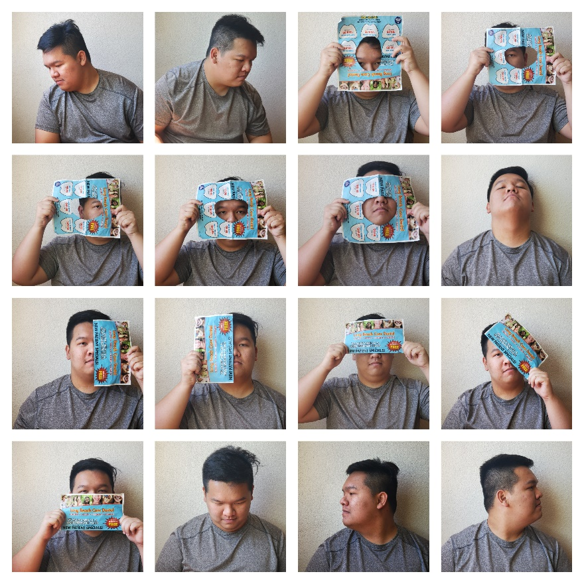

Figure 1: Base case

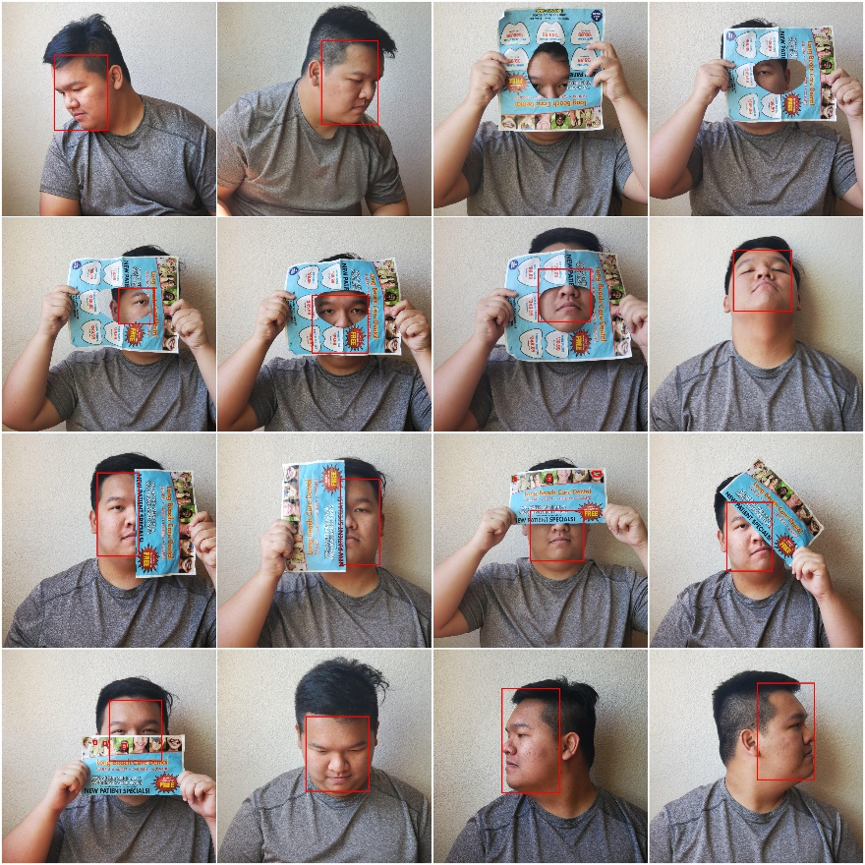

Figure : IoU 0.5



Figure : IoU 0.6

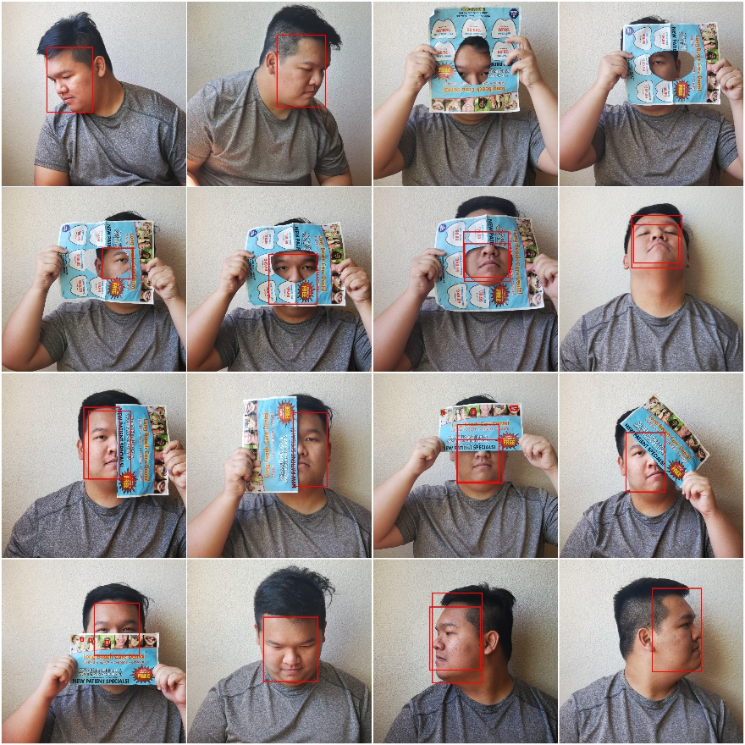

Figure : IoU 0.7

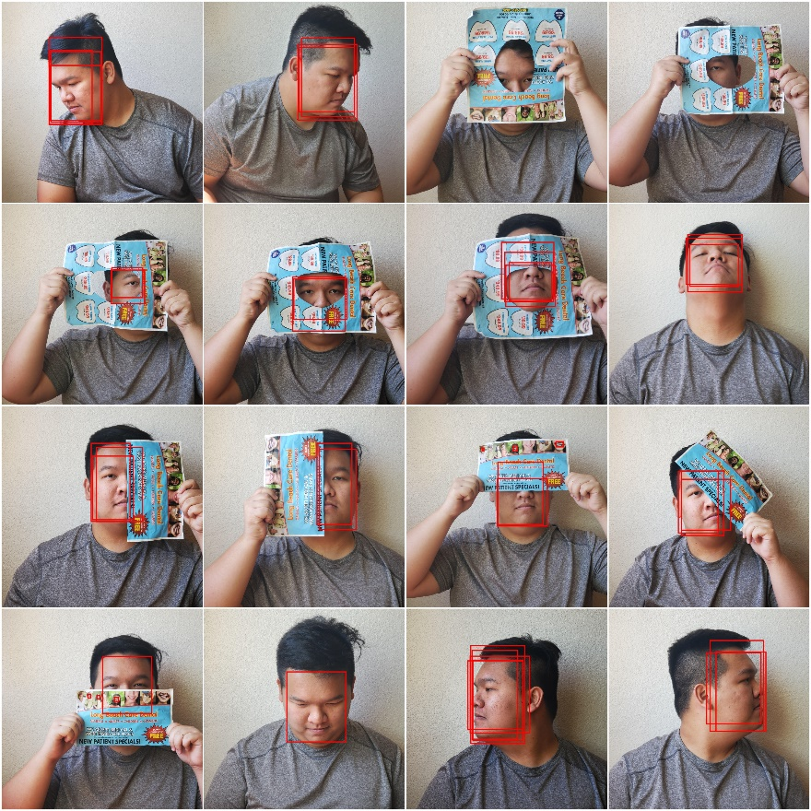

Figure : IoU 0.8

The differences of the predicted results of IoU 0.5 and IoU 0.8 is within expectation. As shown, due to higher IoU threshold, fewer bounding boxes are considered similar and thus less boxes are being eliminated.



Figure : P 0.6

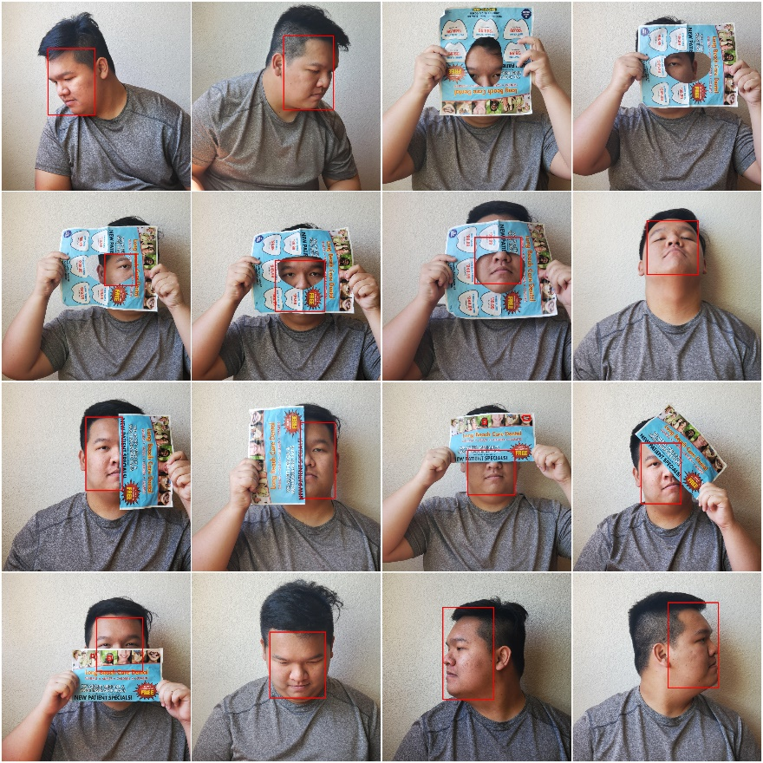

Figure : P 0.7

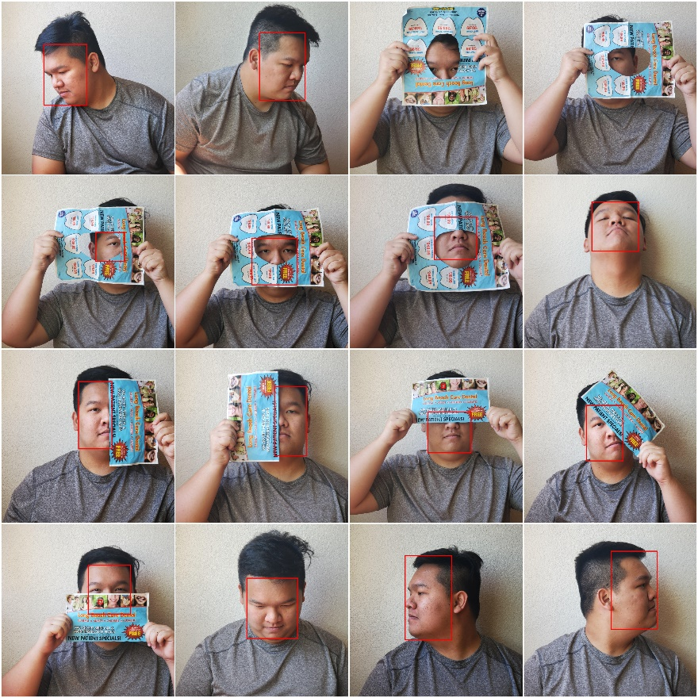

Figure : P 0.8

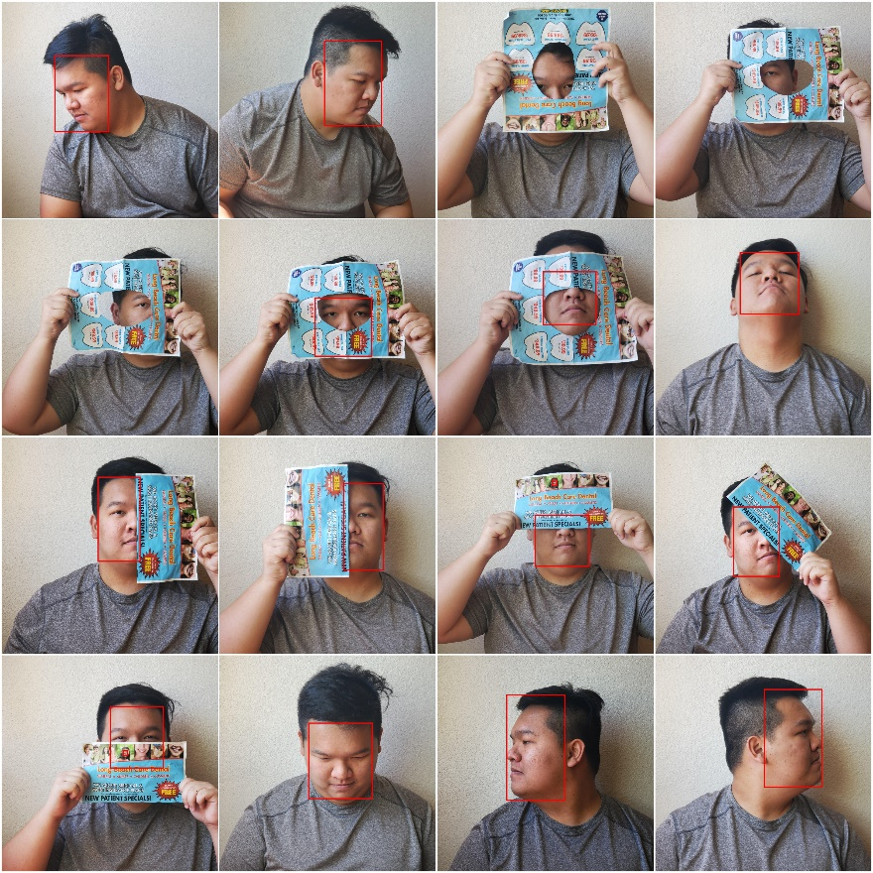

Figure : P 0.9

The results above of varying box threshold are within expectation. By increasing box threshold, bounding boxes with low confident score are being eliminated. For example, increasing box threshold from 0.8 to 0.9, the bounding box of fifth image is eliminated.

Reference

<https://github.com/sthanhng/yoloface>

<https://pjreddie.com/media/files/papers/YOLOv3.pdf>

<https://towardsdatascience.com/yolo-v3-object-detection-53fb7d3bfe6b>

<https://medium.com/@venkatakrishna.jonnalagadda/object-detection-yolo-v1-v2-v3-c3d5eca2312a>